IRSTI 44.37.29

**А.D. Mehdiyev1 (orcid - 0000-0002-2633-3976) - main author**

**Y.Zh. Sarsikeev2 (orcid - 0000-0002-7209-5024)**,

**Y.K. Amir3 (orcid - 0000-0003-0986-0683)**

*1Ph.D. in Technology, associate professor, senior lecturer of the Department of “Electrical Equipment Operation” 2Ph.D. in Technology,*

*Head of the Department of “Electrical Equipment Operation”, 3PhD student, assistant of the Department of “Electrical Equipment Operation”*

*1,2,3NJSC Kazakh Agro-Technical University named after S. Seifullin ",*

*010011, Nur-Sultan, Zhenis ave., 62, Republic of Kazakhstan,*

*e-mail:*[*barton.kz@mail.ru*](mailto:zhumaser@mail.ru)

**DEVELOPMENT OF A MODEL AND CONTROL ALGORITHM FOR A SOLAR TRACKER**

**Abstract.** In this article, a prototype model of a solar tracker and an algorithm for its control based on the "Arduino Uno" platform are being developed. The purpose of this article is to study the subject area, create an autonomous solar tracker model and conduct a study on the production of solar panels. The introduction of a solar tracker is an affordable way to improve the efficiency of solar panels. The solar tracker can already be applied to an operating solar power plant, with a slight redesign of the structure on which solar panels are installed. The solar tracker increases electricity production to a greater extent in the morning and evening, the tracker directs the panels to the maximum flow of sunlight, making production uniform throughout the day. The article shows the results of the experiment and provides a comparative analysis of the production of solar panels. The design of the layout of the solar tracker was developed and the graphs of the dependence of the power of the solar panel on time were drawn up, the calculations of the power of the solar panel and were carried out. A solar tracker control system based on Arduino Uno has been developed. The yield of solar panels with a dual axis and single axis solar tracker is 59.4% and 43% compared to a solar panel installed at 45°.

**Keywords:** renewable energy, electric power, solar energy, solar panel, photovoltaic converter, solar tracker, servo, controller, photoresistor

**Introduction**. A promising area of ​​alternative energy is solar energy, based on the conversion of solar radiation into electrical energy. Every day, a large amount of energy falls on the earth's surface, which is the sun, the energy of the sun has an inexhaustible supply that can be used for your own purposes. The generation of electricity using solar power plants is used today almost all over the world, it is environmentally friendly production of electricity[1].

Sometimes consumers of electrical energy are far from sources of electricity, and it is not profitable for energy companies to stretch power lines, since electricity losses are high. Then it is optimal to give preference to alternative energy based on solar panels or wind generators. The advantage of solar energy in the absence of hazardous waste in the production of electricity, high reliability, solar energy can be used anywhere.

A serious disadvantage of using solar energy is the high cost of energy produced in comparison with conventional energy sources. Long payback. There is a low tariff for “Green Electricity” in Kazakhstan. The tariff for electricity produced by wind turbines is 22.66 tenge per kWh. The tariff for electricity produced by solar panels is 34.60 tenge per kWh. The tariff for the hydroelectric power station is 16.70 tenge. The tariff for biogas plants is 32.23 tenge[2]. For 2019, in Ukraine, the “green tariff” for electricity produced by solar panels is 0.18 euros, which is 76.79 tenge, which is 2 times more than in Kazakhstan[3]. Therefore, solar installations delivered in Ukraine pay off 2 times faster. What makes alternative energy attractive. In Ukraine, electricity sellers to the state can be individuals and legal entities. In Kazakhstan, only legal entities can sell electricity “at the green rate”.

**Conditions and research methods.** As a rule, the solar tracker has a rotary mechanism. Since a two-axis solar tracker is being designed in this work, it must have two degrees of freedom. This can be done using two movable platforms: a base and a platform on which the solar panel will be mounted.

The structure in Figure 1 was developed in the Compass-3D program, and was cut according to the drawings with a laser cutting machine from 0.6 cm plywood.The components are attached to each other using 4×3.5 cm screws with an M5 bolt in the amount of 20 pcs and one screws 4×5.5 cm.

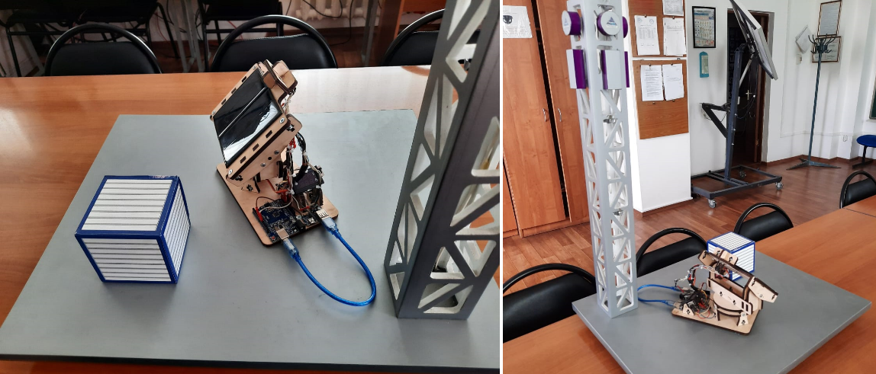

Figure 1 - Dummy model of the solar tracker

Due to the price difference, the Arduino Uno control board shown in Figure 2 was chosen because it has proven itself in the market. The board has a simple and intuitive interface both at the software and hardware levels. The board has a high data processing speed that will allow the solar tracker's control mechanisms to respond instantly to changes in solar activity. The Arduino UNO board has 6 ADC input ports. One or all can be used as analog voltage inputs. The Arduino Uno ADC has 10-bit resolution. This means that it will display input voltages ranging from 0 to 5 volts to integer values ​​between 0 and 1023[4].

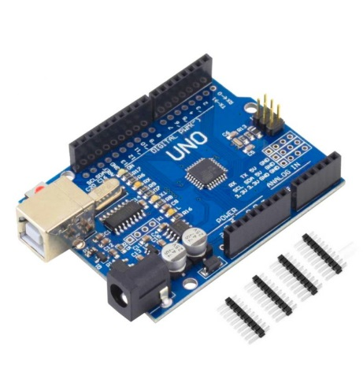

Figure 2 - Board "Arduino Uno"

The SG92R 9G servo is a slewing drive that provides precise control in terms of angular position, acceleration and speed. Basically, it has certain capabilities that a regular motor does not have.

The servo can rotate from 0 to 180 degrees. This degree of rotation can be controlled by applying an electrical pulse of the correct width to the control input. Also, this servo is characterized by metal gears and a torque value of 2.5kg/cm[5].

Solar sensor. The main function of solar sensors is to provide accurate and reliable tracking of the position of the sun. Based on research on various methods of detecting light, photoresistors, photodiodes and photocells have been found to be suitable for possible sensors[6].

Photoresistors connected according to the voltage divider circuit will be used as photosensitive elements. The sun, due to its movement, changes the direction of the rays, so some of the photoresistors are in the shadow or, on the contrary, illuminated. The algorithm of the sensor has 9 commands. The solar sensor is shown in Figure 3.

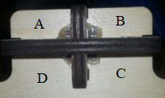

Figure 3 - Solar sensor

Possible sensor illumination options are presented in Tables 1.1 and 1.2.

Table - 1.1

Possible sensor illumination options for a biaxial solar tracker

|  |  |  |  |  |  |
| --- | --- | --- | --- | --- | --- |
| Sensor A | 1 | 0 | 1 | 1 | 0 |
| Sensor B | 0 | 1 | 1 | 0 | 0 |
| Sensor C | 0 | 0 | 0 | 0 | 1 |
| Sensor D | 0 | 0 | 0 | 1 | 0 |
| Note | Sun higher and west | Sun higher and east | The sun is higher | The sun is west | Sun below and east |
| Vertical movement | Up | Up | Up | Stand | Way down |
| Horizontal movement | To the west | To the East | Stop | To the west | To the East |

In table 1.1 and 1.2, numbers 1 and 0 indicate the illumination levels of the sensors. A one means that the photoresistor is illuminated more than the others. Accordingly, zero means shading of the photoresistor. The note shows the position of the sun in relation to the solar sensor. The tables also indicate the directions of movement of the solar tracker, depending on the position of the sun or, in other words, the illumination of the sensor photoresistors[7].

Table - 1.2

Possible sensor illumination options for a biaxial solar tracker

|  |  |  |  |  |
| --- | --- | --- | --- | --- |
| Sensor A | 0 | 0 | 0 | 1 |
| Sensor B | 1 | 0 | 0 | 1 |
| Sensor C | 1 | 1 | 0 | 1 |
| Sensor D | 0 | 1 | 1 | 1 |
| Note | The sun is east | Sun below | The sun is lower and west | Like the sun |
| Vertical movement | Stop | Way down | Way down | Stop |
| Horizontal movement | To the East | Stop | To the west | Stop |

The principle of operation of the solar sensor is based on the change in the resistance of the photoresistors, depending on the incidence of sunlight, and the intensity of the luminous flux changes the resistance on the photoresistors. The voltage divider circuit translates the analog values ​​into a voltage in the range of 0 to 5 volts and provides a digital output number that ranges from 0 to 1023. This is necessary for feedback to the Arduino Uno microcontroller[8].

In order to control the solar tracker, it is necessary to program the Arduino Uno microcontroller in the C ++ programming language. The main block diagrams are shown in Figures 4, 5 and 6. Figure 7 shows the principal schematics of dummy model layout and pinout[9].

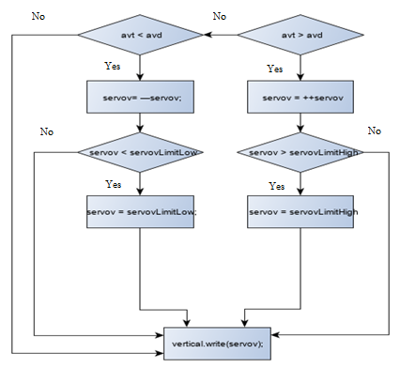

Figure 4 - Vertical servo control program

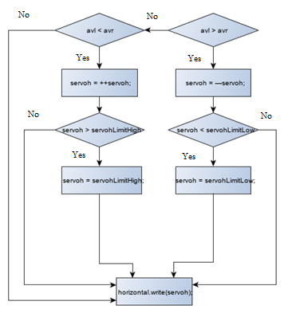

Figure 5 - Horizontal servo control program

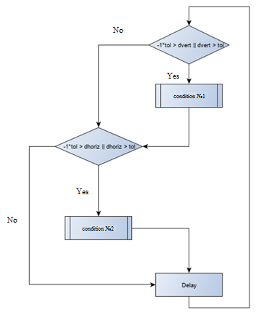

Figure 6 - General block diagram of the algorithm

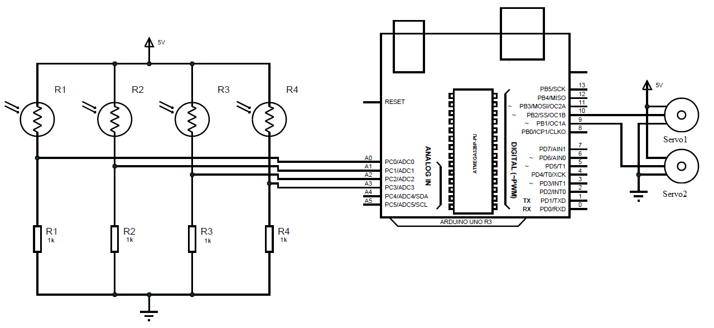

Figure 7 – Dummy model pinout on Arduino UNO board

**Research results.** In order to conduct an experiment and identify the most optimal orientation system from the investigated, the following configurations of solar panels were taken.

1) Horizontally mounted panel.

2) Installed at a 45° angle.

3) Using a single axis tracker.

4) Using a dual axis solar tracker.

All experimental installations are directed to the South.

The experiment was carried out starting from 12 noon (the time of the peak of the sun in the city of Karaganda) with an interval of 15 minutes.

During the experiment, 36 values ​​of voltage and current were obtained; the data were entered into the appropriate tables for subsequent analysis of the data obtained. Power has been calculated and charts have been drawn[10].

To calculate the power of a solar panel, first determine the amount of solar radium that falls to the ground. To determine the amount of solar radiation, you need formula 3.1.

Srad = Sr(max) ∙ Kmass ∙ cosα, (3.1)

where Sr(max) - The amount of solar radiation coming from the Sun is 1312W / m2. Since 30-40% of the energy is reflected from the earth's surface, we will consider Sr(max) = 812 W / m ^ 2.

α - is the angle at which the sun's rays fall on the surface,

Kmass - is the air mass correction factor.

Based on the data obtained, schedules for the power generation of solar panels for 4 types of orientation systems were drawn up. Figure 8 shows a graph of the evolution of solar panel production over time. The graphs show that the generated power at 12 noon is almost the same for everyone except for the horizontally installed panel. Because panel deflection of 45° reduces yield by 30% - 40%. The development with a biaxial system oriented is practically the same with a uniaxial solar tracker. The dual axis solar tracker provides an 18% increase in power generation compared to a single axis system. The power generation of a horizontally mounted panel is 78.5% less than that of a biaxial system. And the solar panel installed at 45 ° produces 59.4% less than the biaxial system. The uniaxial system has 43% more power generation than a solar panel mounted at a 45° angle. The experimental data generally support the data that were obtained as a result of calculating the power of solar energy for a solar panel with an area of ​​1m2[11].

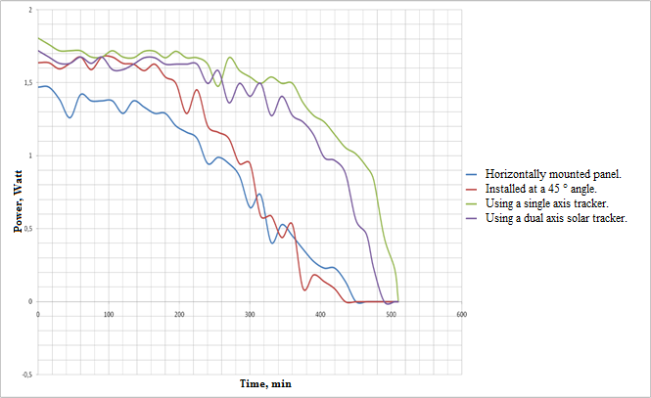

Figure 8 - A graph of the change in the production of solar panels over time

**Discussion of scientific results**. In the course of the work carried out in this article, empirical data on the topic of study were obtained. Also, the software for the solar tracker controller was studied and developed in the C / C ++ programming language. The system of modeling and design of electronic devices “Proteus” has been studied.

The field of application of this scientific work is renewable electric power industry and those systems in which autonomous power sources based on photovoltaic modules are used. The solar tracker can be used to improve the efficiency of a solar power plant of base stations of telecommunication systems, as well as this device can be used for operating solar power plants. The created model of an autonomous solar tracker can be used for a demonstration manual for teaching students or for work with applicants. A solar tracker control system based on Arduino Uno has been developed, which has increased the generation of electrical energy up to 60%. The increase in electricity generation for solar panels with biaxial and uniaxial orientation is 59.

**Сonclusion**. This article conducted a study of the subject area, studied the stages of development of solar energy, considered the types of photovoltaic converters, studied the problems of solar energy and ways to solve them.

It was also shown the development of the solar tracker in stages. The block diagram of the algorithm was made. On the block diagram was composed code for the Arduino environment in the C++ programming language.

Then, the calculation of the solar panel output depending on the month. The calculation showed that the total for the year single-axis orientation system gives an increase of 45% and the two-axis system gives 60% in contrast to the permanently installed solar panel.

Finally, the results of the experiment were shown and a comparative analysis of solar panel output was performed. Plots of the solar panel output versus time were made. The output of the solar panels with two-axis and single-axis solar tracker is 59.4% and 43% compared to the solar panel mounted at 45°.

The experimental data generally confirm the data obtained by calculating the solar power output for a solar panel with an area of 1m2.

**List of references**

1. K. Azizi and A. Ghaffari, “Design and manufacturing of a high-precision sun tracking system based on image processing,” International Journal of Photoenergy, vol. 2013, Article ID 754549, 7 pages, 2013
2. Alexandru, C. Modeling and Simulation of the Tracking Mechanism Used For a Photovoltaic Platform. In Proceedings of the 3rd European Conference on Mechanism Science—EUCOMES, Cluj-Napoca, Romania, 14–18 September 2010; pp. 575–582. [Google Scholar]
3. E. Lorenzo, M. Pérez, A. Ezpeleta, and J. Acedo, “Design of tracking photovoltaic systems with a single vertical axis,” Progress in Photovoltaics: Research and Applications, vol. 10, no. 8, pp. 533–543, 2002.
4. Hoffmann, F.M.; Molz, R.F.; Kothe, J.V.; Nara, E.O.B.; Tedesco, L.P.C. Monthly profile analysis based on a two-axis solar tracker proposal for photovoltaic panels. Renew. Energy 2018, 115, 750–759. [Google Scholar] [CrossRef]
5. Hammad, B.; Al-Sardeah, A.; Al-Abed, M.; Nijmeh, S.; Al-Ghandoor, A. Performance and economic comparison of fixed and tracking photovoltaic systems in Jordan. Renew. Sustain. Energy Rev. 2017, 80, 827–839. [Google Scholar] [CrossRef]
6. N. Kuttybay, S. Mekhilef, A. Saymbetov, M. Nurgaliyev, and Z. Kopzhan, “An automated intelligent solar tracking control system with adaptive algorithm for different weather conditions,” in Proceedings of the 2019 IEEE International Conference on Automatic Control and Intelligent Systems (I2CACIS), IEEE, Shah Alam, Malaysia, June 2019.
7. J. Wu, B. Zhang, and L. Wang, “Optimum design and performance comparison of a redundantly actuated solar tracker and its nonredundant counterpart,” Solar Energy, vol. 127, pp. 36–47, 2016.
8. Saad M, El Hammoumi A, El Ghzizal A (2020) The most used MPPT algorithms: review and the suitable low-cost embedded board for each algorithm. J Clean Prod 246:118983
9. Morón, C.; Ferrández, D.; Saiz, P.; Vega, G.; Díaz, J.P. New prototype of photovoltaic solar tracker based on Arduino. Energies 2017, 10, 1298. [Google Scholar] [CrossRef]
10. Seme, S.; Štumberger, B.; Hadžiselimovic, M.; Sredenšek, K. Solar photovoltaic tracking systems for electricity generation: A review. Energies 2020, 13, 4224. [Google Scholar] [CrossRef]
11. Henriques, D.; Tiba, C. npTrack: A n-Position Single Axis Solar Tracker Model for Optimized Energy Collection. Energies 2021, 14, 925. [Google Scholar]

Материал поступил в редакцию 22.02.2022.

**А.Д. Мехдиев**1**, Е.Ж. Сарсикеев**2**, Е.К. Амир**3

*1,2,3С.Сейфуллин атындағы Қазақ агротехникалық университеті»,*

*010011, Нұр-Сұлтан, Жеңіс даңғылы, 62, Қазақстан Республикасы,*

**КҮН СӘУЛЕСІ ТРЕККРІНІҢ МОДЕЛІН ЖӘНЕ БАСҚАРУ АЛГОРИТМІН ЖОБАЛАУ.**

**Аннотация.** Бұл мақалада «Arduino Uno» платформасына негізделген күн трекерінің прототипі моделі және оны басқару алгоритмі әзірленуде. Бұл мақаланың мақсаты – тақырыпты зерттеу, күн трекерінің автономды моделін құру және күн батареяларын өндіру бойынша зерттеулер жүргізу. Күн трекерін енгізу күн батареяларының тиімділігін арттырудың қолжетімді әдісі болып табылады. Күн трекерін күн панельдеріне қосыла орнатылуы арқылы күн электр станцияларында қолдануға болады. Күн трекері электр энергиясын өндіруді таңертең және кешкі уақытта тиімді жүргізуі мақсатында, трекер панельдерді күн сәулесінің максималды ағынына бағытталады, бұл энергия өндірісін күні бойы біркелкі етеді. Мақалада эксперимент нәтижелері мен күн батареяларының өндірісінің салыстырмалы талдауы көрсетілген. Күн трекерінің макетінің дизайны жасалды және күн батареясының қуатының уақытқа тәуелділігінің графиктері құрылды. Күн батареясының қуатын есептеу жүргізілді. Arduino Uno негізінде күн трекерін басқару жүйесі жасалды. Қос осьті және бір осьті күн трекері бар күн батареяларының шығымы 45°-қа орнатылған күн батареясымен салыстырғанда 59,4% және 43% құрайды.

**Тірек сөздер:** жаңартылатын энергия, электр энергиясы, күн энергиясы, күн панелі, фотоэлектрлік түрлендіргіш, күн трекері, серво, контроллер, фоторезистор

**А.Д. Мехтиев**1**, Е.Ж. Сарсикеев**2**, Е.К. Амир**3

*1,2,3НАО «Казахский агротехнический университет им. С.Сейфуллина»,*

*010011, г. Нур-Султан, пр. Жеңіс, 62, Республика Казахстан*

**РАЗРАБОТКА МАКЕТНОЙ МОДЕЛИ И АЛГОРИТМА УПРАВЛЕНИЯ СОЛНЕЧНОГО ТРЕКЕРА**

**Аннотация.** В данной статье разрабатывается макетная модель солнечного трекера и алгоритм ее управления на базе платформы «Arduino Uno». Целью данной статьи является исследование предметной области, создание автономного макета солнечного трекера и проведение исследования выработки солнечных панелей. Введение солнечного трекера является доступным способом повышения эффективности солнечных панелей. Солнечный трекер может быть применен уже на действующую солнечную электростанцию, с небольшой переделкой конструкции на которой установлены солнечные панели. Данное устройсво повышает выработку электроэнергии в большей степени утром и вечером, трекер направляет панели на максимальный поток солнечных лучей, делая производство равномерным в течении всего светового дня. В статье показаны результаты эксперимента и проведен сравнительный анализ выработки солнечный панелей. Была разработана конструкция макета солнечного трекера и были построены графики зависимости мощности солнечной панели от времени проведены расчеты мощности солнечной панели и. Разработана система управления солнечным трекером на базе Arduino Uno. Выработка солнечных панелей с двухосевым и одноосевым солнечным трекером составляет 59,4% и 43% в сравнении солнечной панелью, установленной под 45°.

**Ключевые слова:** возобновляемые источники энергии,электроэнергетика, солнечная энергия, солнечная панель, фотоэлектрических преобразователь, солнечный трекер, сервопривод, контроллер

**Список литературы**

1. K. Azizi and A. Ghaffari, “Design and manufacturing of a high-precision sun tracking system based on image processing,” International Journal of Photoenergy, vol. 2013, Article ID 754549, 7 pages, 2013
2. Alexandru, C. Modeling and Simulation of the Tracking Mechanism Used For a Photovoltaic Platform. In Proceedings of the 3rd European Conference on Mechanism Science—EUCOMES, Cluj-Napoca, Romania, 14–18 September 2010; pp. 575–582. [Google Scholar]
3. E. Lorenzo, M. Pérez, A. Ezpeleta, and J. Acedo, “Design of tracking photovoltaic systems with a single vertical axis,” Progress in Photovoltaics: Research and Applications, vol. 10, no. 8, pp. 533–543, 2002.
4. Hoffmann, F.M.; Molz, R.F.; Kothe, J.V.; Nara, E.O.B.; Tedesco, L.P.C. Monthly profile analysis based on a two-axis solar tracker proposal for photovoltaic panels. Renew. Energy 2018, 115, 750–759. [Google Scholar] [CrossRef]
5. Hammad, B.; Al-Sardeah, A.; Al-Abed, M.; Nijmeh, S.; Al-Ghandoor, A. Performance and economic comparison of fixed and tracking photovoltaic systems in Jordan. Renew. Sustain. Energy Rev. 2017, 80, 827–839. [Google Scholar] [CrossRef]
6. N. Kuttybay, S. Mekhilef, A. Saymbetov, M. Nurgaliyev, and Z. Kopzhan, “An automated intelligent solar tracking control system with adaptive algorithm for different weather conditions,” in Proceedings of the 2019 IEEE International Conference on Automatic Control and Intelligent Systems (I2CACIS), IEEE, Shah Alam, Malaysia, June 2019.
7. J. Wu, B. Zhang, and L. Wang, “Optimum design and performance comparison of a redundantly actuated solar tracker and its nonredundant counterpart,” Solar Energy, vol. 127, pp. 36–47, 2016.
8. Saad M, El Hammoumi A, El Ghzizal A (2020) The most used MPPT algorithms: review and the suitable low-cost embedded board for each algorithm. J Clean Prod 246:118983
9. Morón, C.; Ferrández, D.; Saiz, P.; Vega, G.; Díaz, J.P. New prototype of photovoltaic solar tracker based on Arduino. Energies 2017, 10, 1298. [Google Scholar] [CrossRef]
10. Seme, S.; Štumberger, B.; Hadžiselimovic, M.; Sredenšek, K. Solar photovoltaic tracking systems for electricity generation: A review. Energies 2020, 13, 4224. [Google Scholar] [CrossRef]
11. Henriques, D.; Tiba, C. npTrack: A n-Position Single Axis Solar Tracker Model for Optimized Energy Collection. Energies 2021, 14, 925. [Google Scholar]

*ФИО автора ответственного за переписку с редакцией: Амир Ерлан Камалиевич*

*номер телефона (WhatsApp +7708 919 4616)*